**Guide for setting up the Amazon RDS Environment.**

1. Select “*Ohio*” from the top-right dropdown list. *Ohio* is the Amazon AWS data center where we want to set up the RDS database. Then, on the top-left, click Services, then Database and finally RDS.

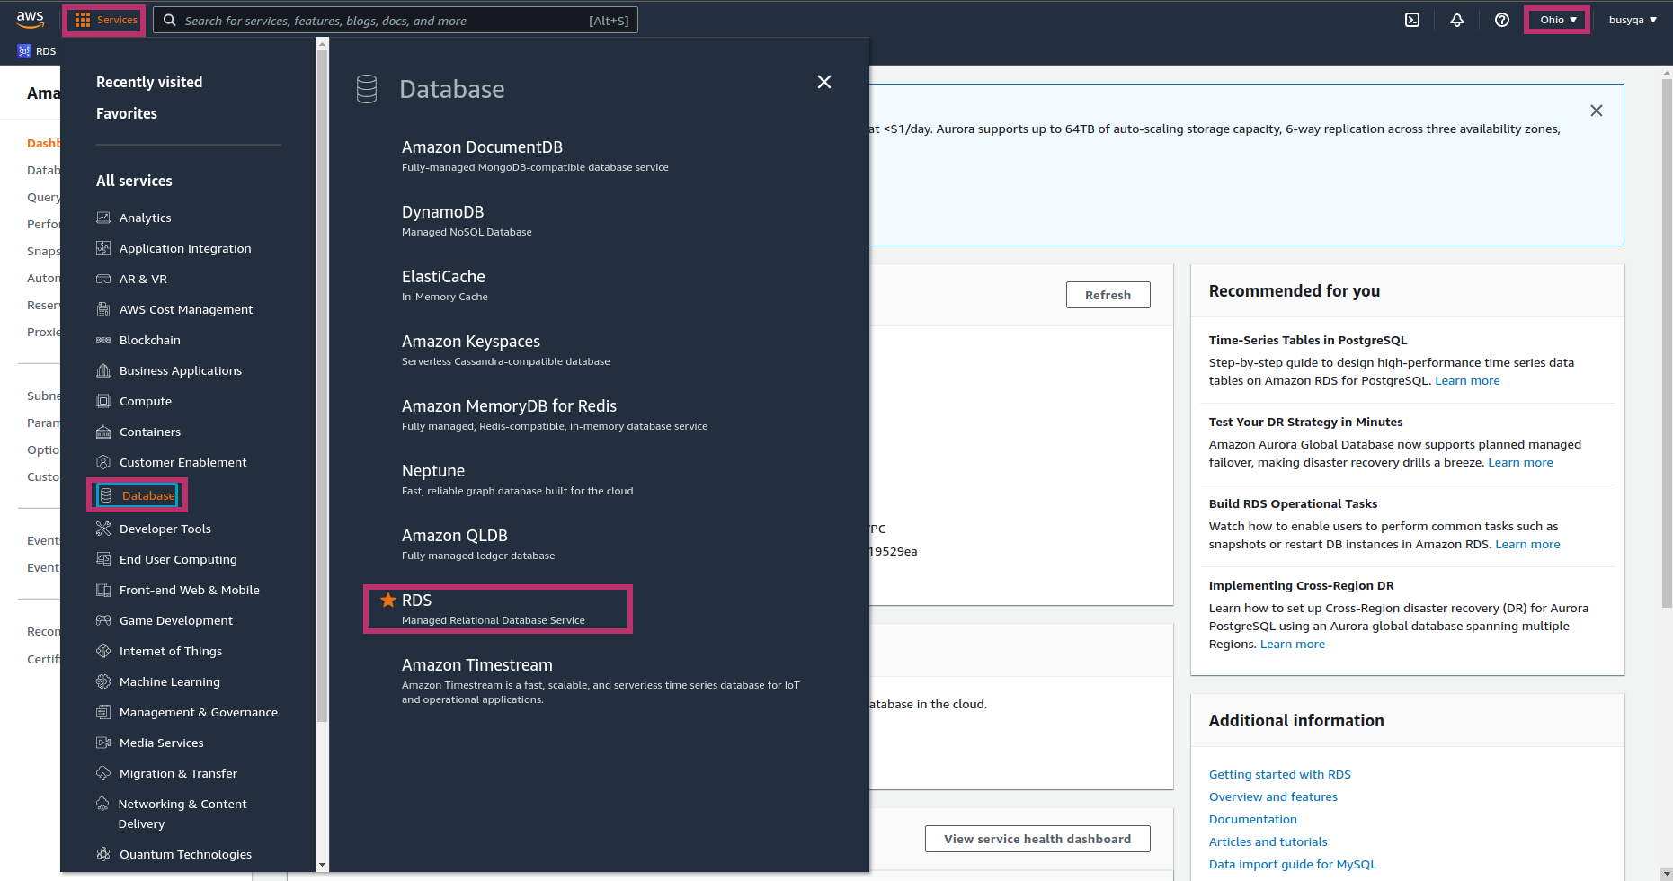

1. Select “*Parameter groups”* from the left menu. Then hit the “*Create parameter group*” orange button.

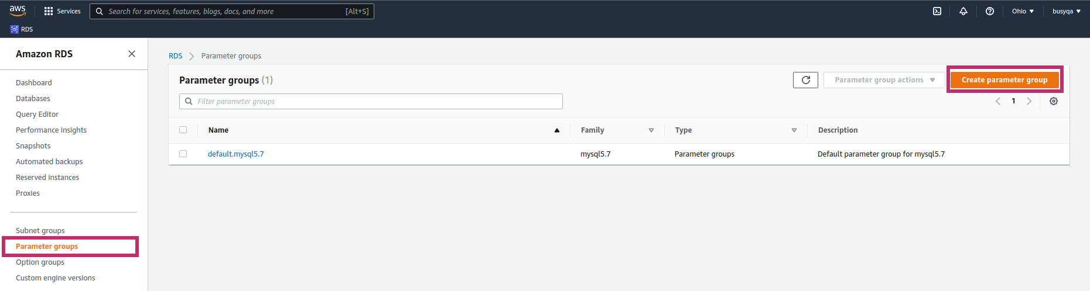

1. Fill out the form as indicated below, then hit the “*Create*” orange button.

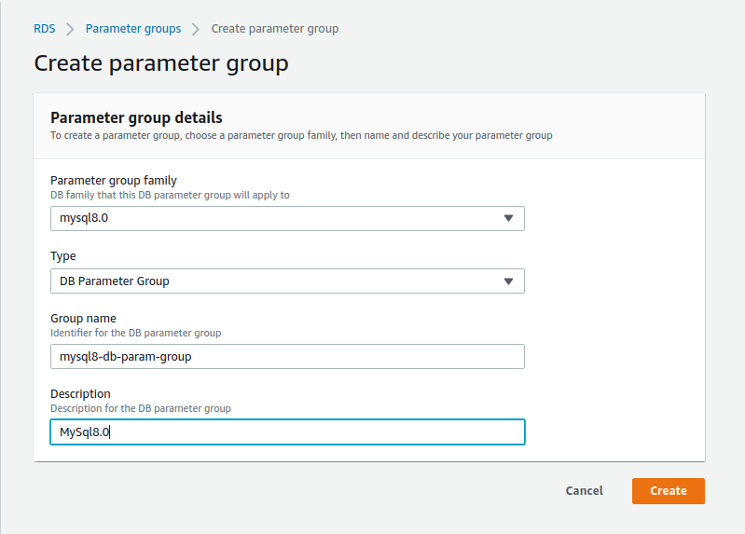

1. Check off the *“mysql8-db-param-group”* item listed, then select “*Edit*” from the dropdown menu.

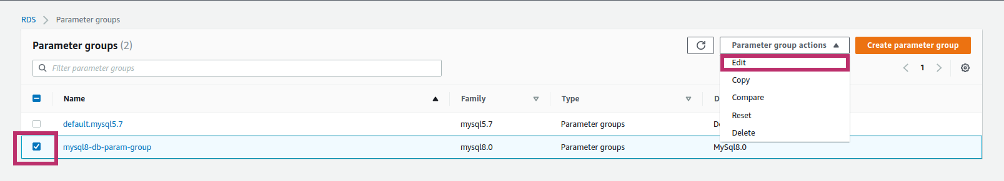

1. Search for the *“lower_case_table_names”* parameter, then change the parameter value to “1”, and finally hit the “Save changes” button.

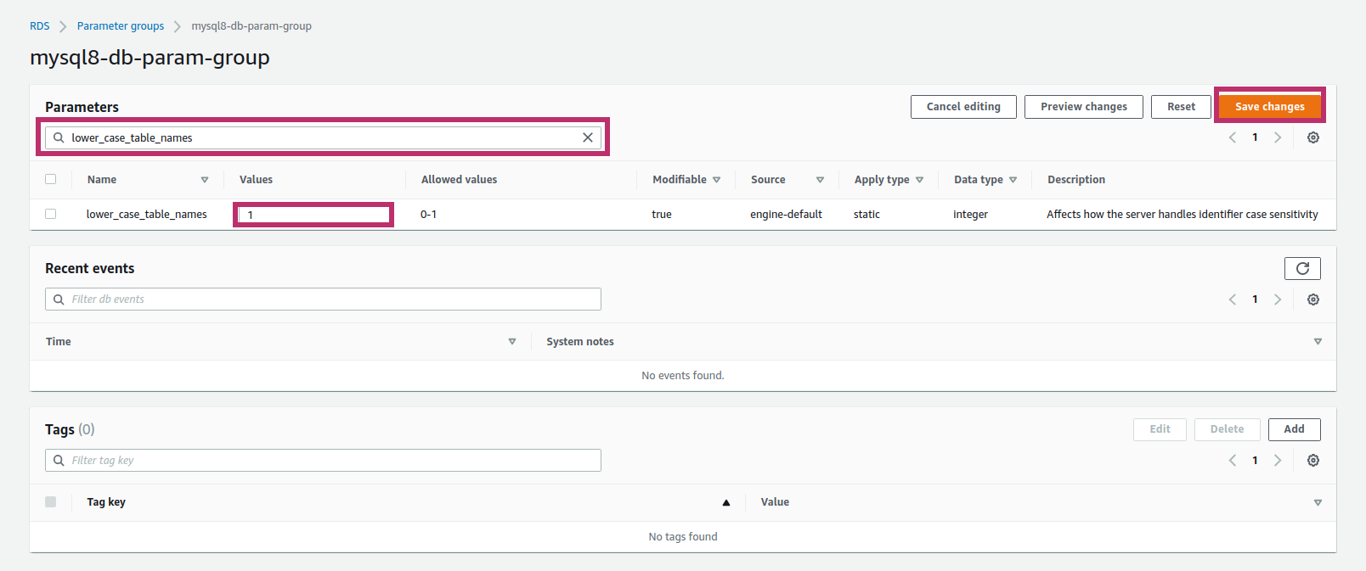

1. Select “*Databases”* from the left menu. Then hit the “*Create database*” orange button.

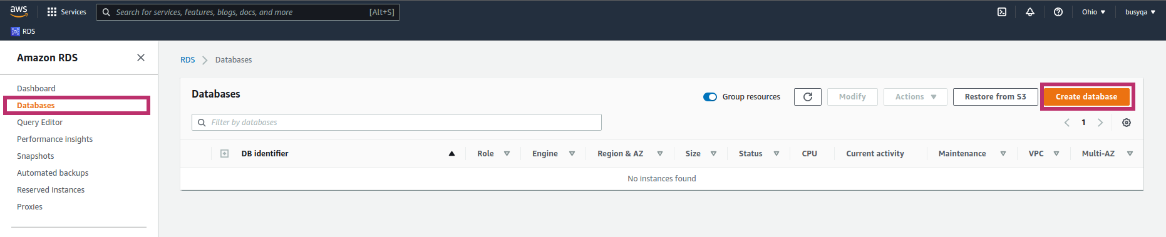

1. Select the options as indicated below.

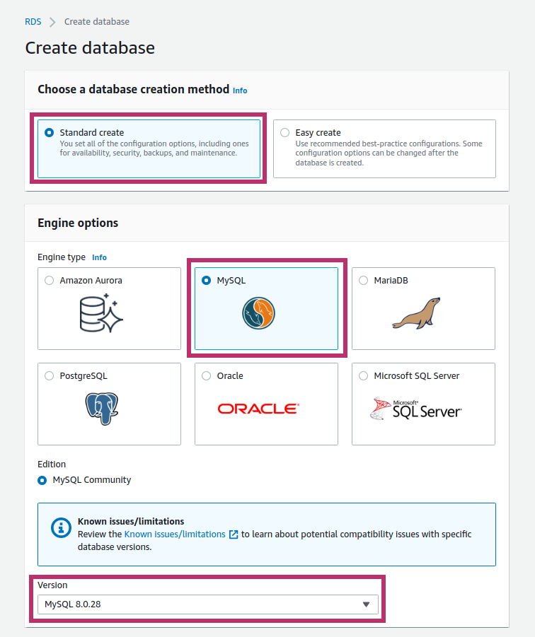

1. Scroll down, select *“Free Tier,”* and fill out the settings as indicated below.

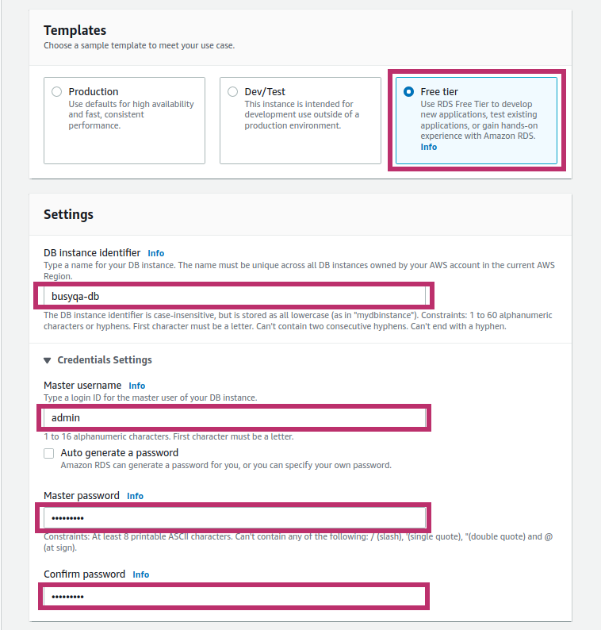

1. Scroll down and keep the default settings.

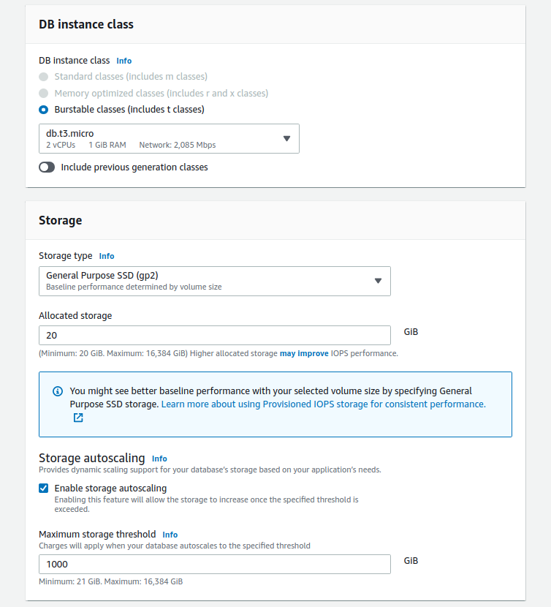

1. Scroll down and select *“Yes”* for Public Access. Keep the rest as is.

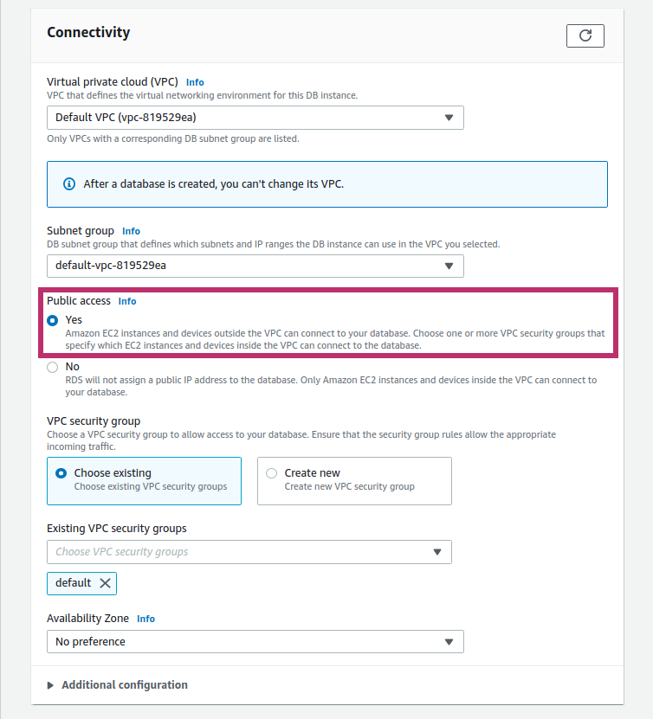

1. Scroll Down, click on *“Additional Configuration,”* then select *mysql8-db-param-group* from the dropdown menu. Finally, uncheck the automated backups and the encryption options as indicated below. Keep the rest options as is.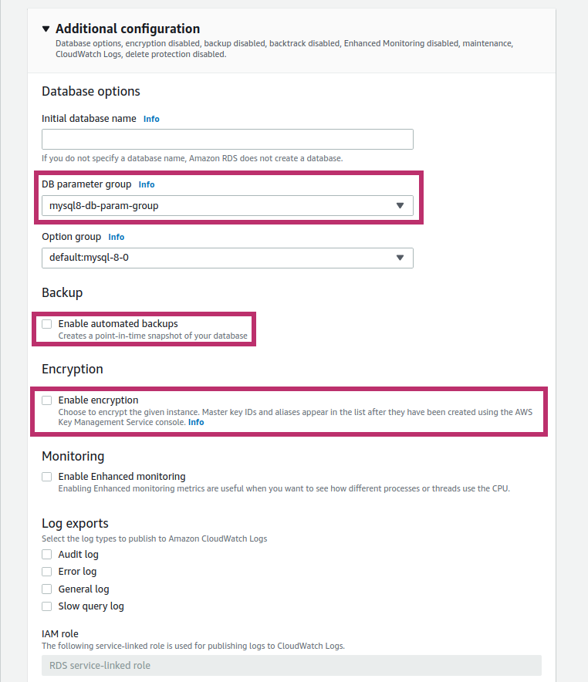
2. Scroll Down, then hit the “*Create database*” orange button.

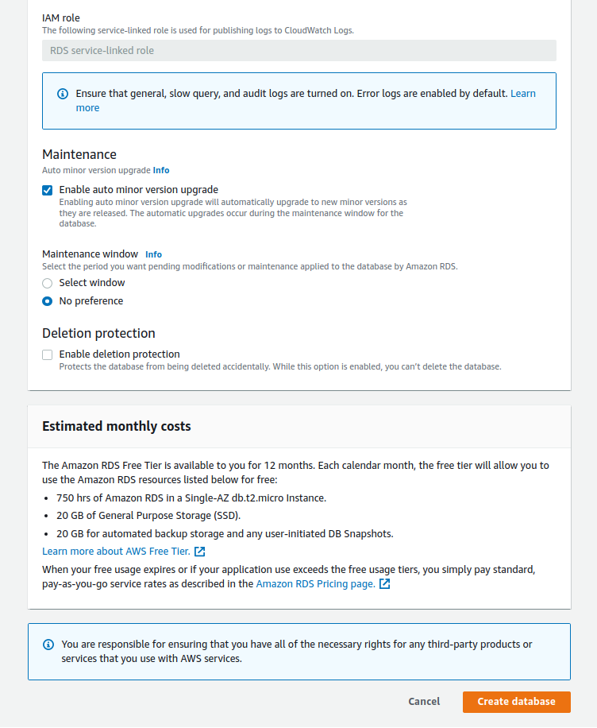

1. Wait for a few minutes until the database shows Status *Available*. Then hit the DB Identifier “*busyqa-db*.”

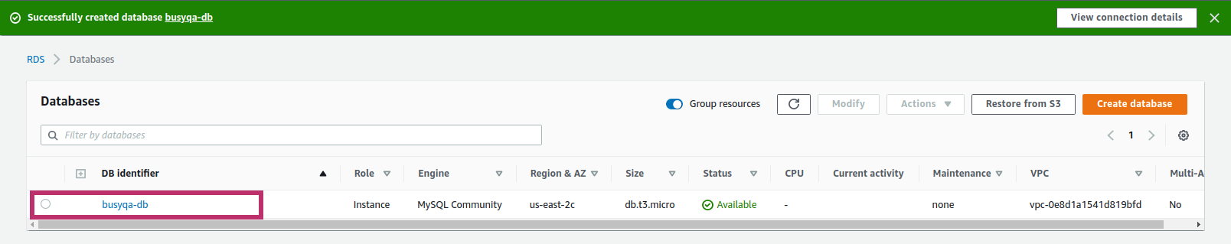

1. Click on the link below “*VPC security groups.”*

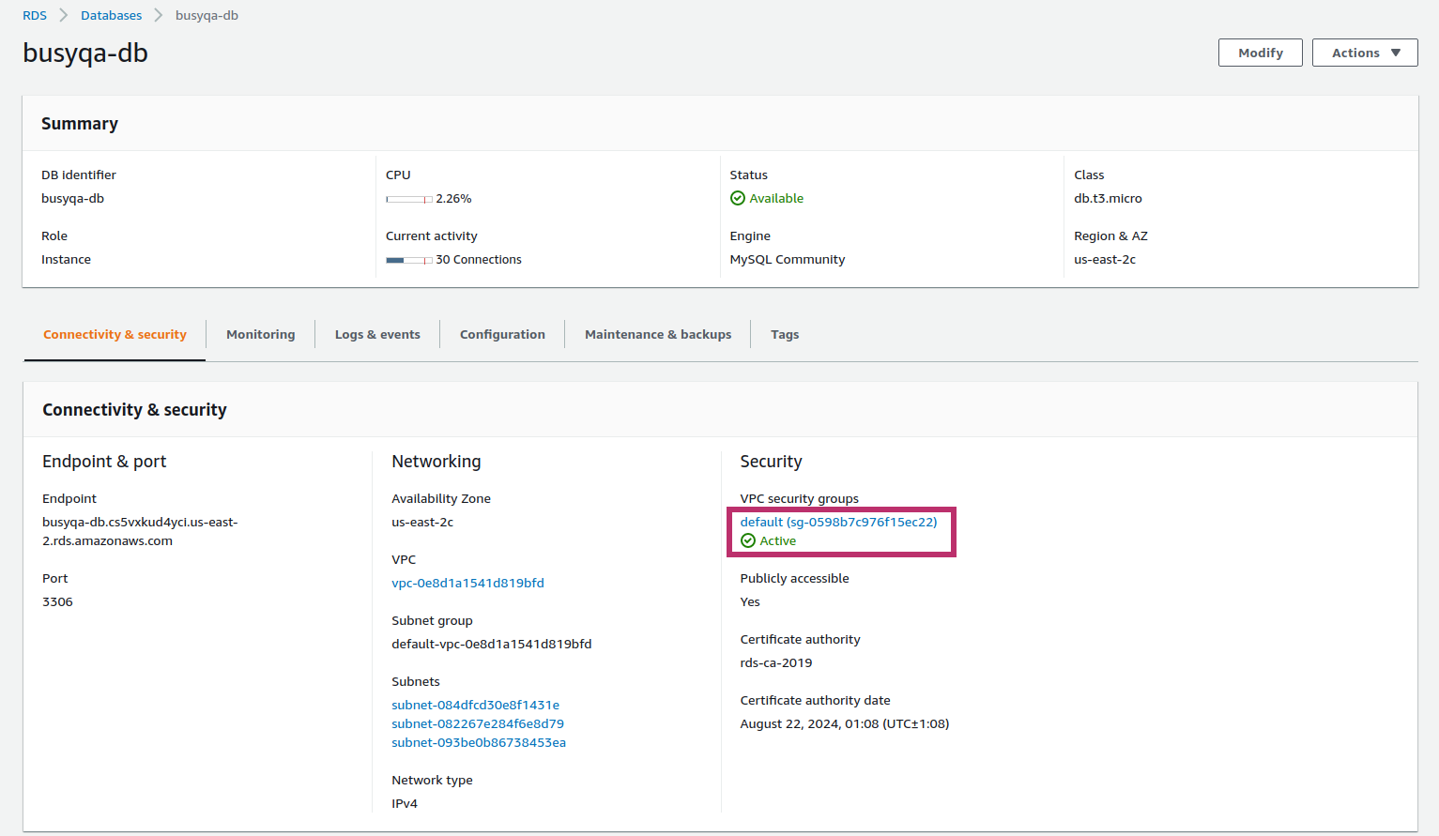

1. Click on *“Inbound rules,”* then *“Edit Inbound rules.”*
2. 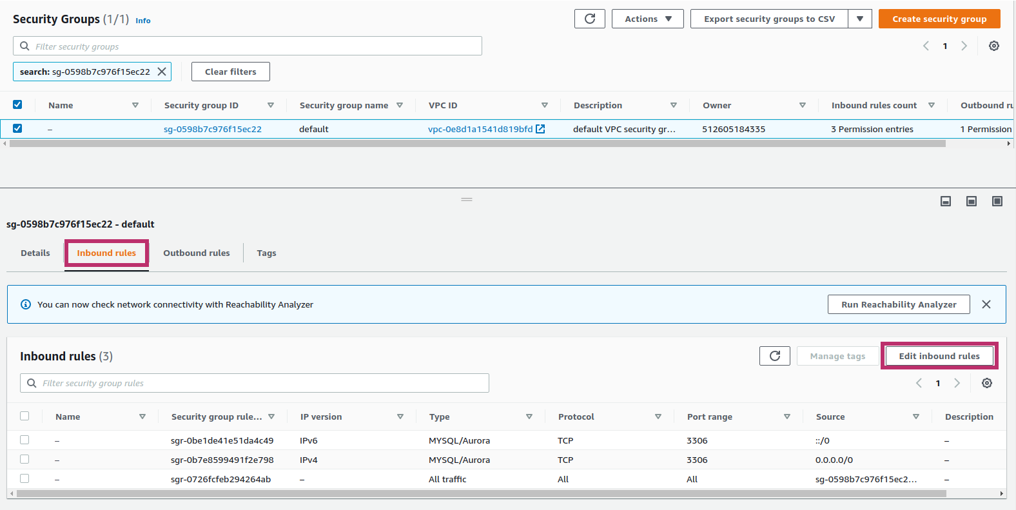Add two MYSQL/Aurora Inbound rules. One with source *“Anywhere-IPv4”* and another with source *“Anywhere-IPv6”*. Then hit “Save Rules.”

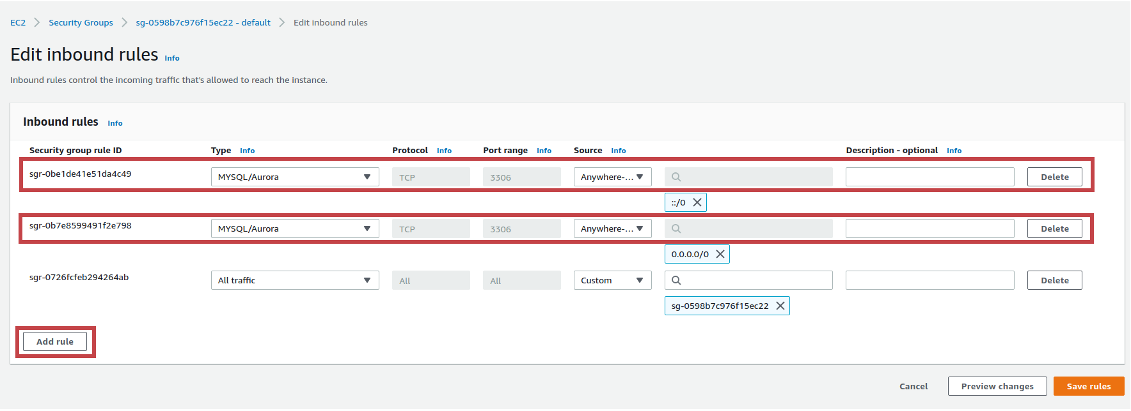

1. Click on “*RDS*” at the top left of your screen.

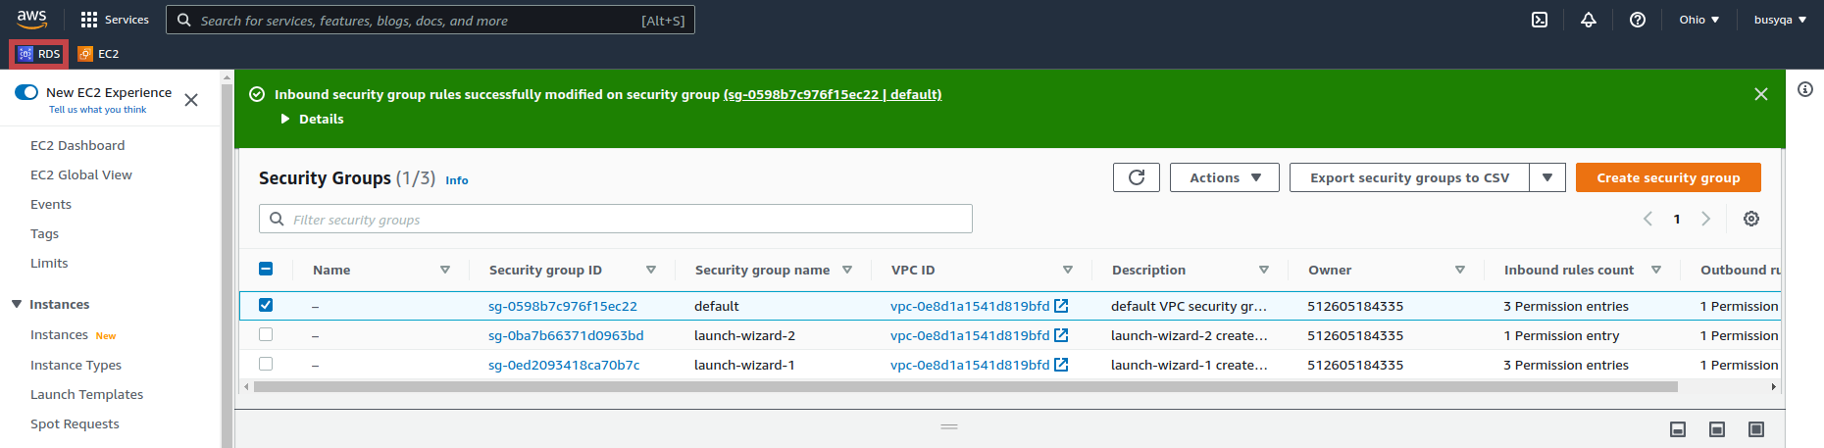

1. Click on “*Databases*” then on “*busyqa-db.*”

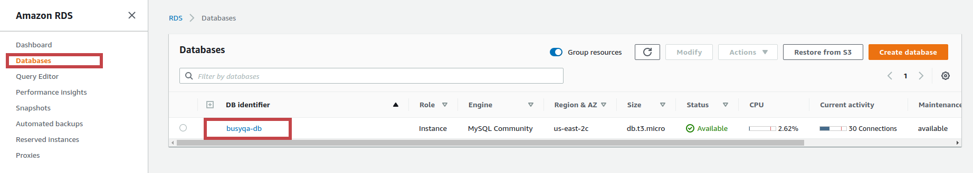

1. The Database URL is displayed below. You will use it in the next step.

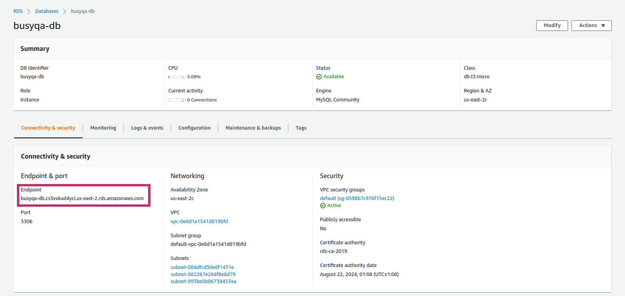

1. To test the database accessibility:

Windows users must open a command prompt and navigate to the folder:

*C:\\Program Files\MySQL\MySQl Server 8.0\bin.* Ensure that you have MySQL Server 8 installed on your computer first.

macOS and Linux users must open a Terminal.

Then run the command below:

**mysql -u admin -p -h [paste your database URL here]**

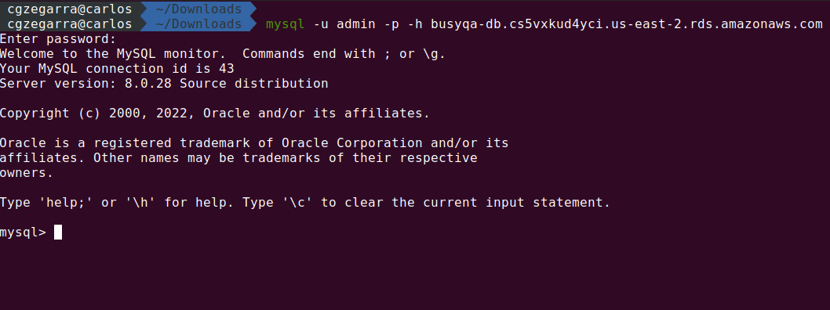

//End